SWADHARMA SERVICES
Front-End Architecture & UX Rewire Specification
Developer handoff • Landing / Discovery / Network / Request Flow

Core decision: Yes — a structured Top Navigation + contextual Side Navigation is better suited to Swadharma than one long landing page. The landing screen should become a compact orientation and service-discovery surface, while the application and directory carry the depth.
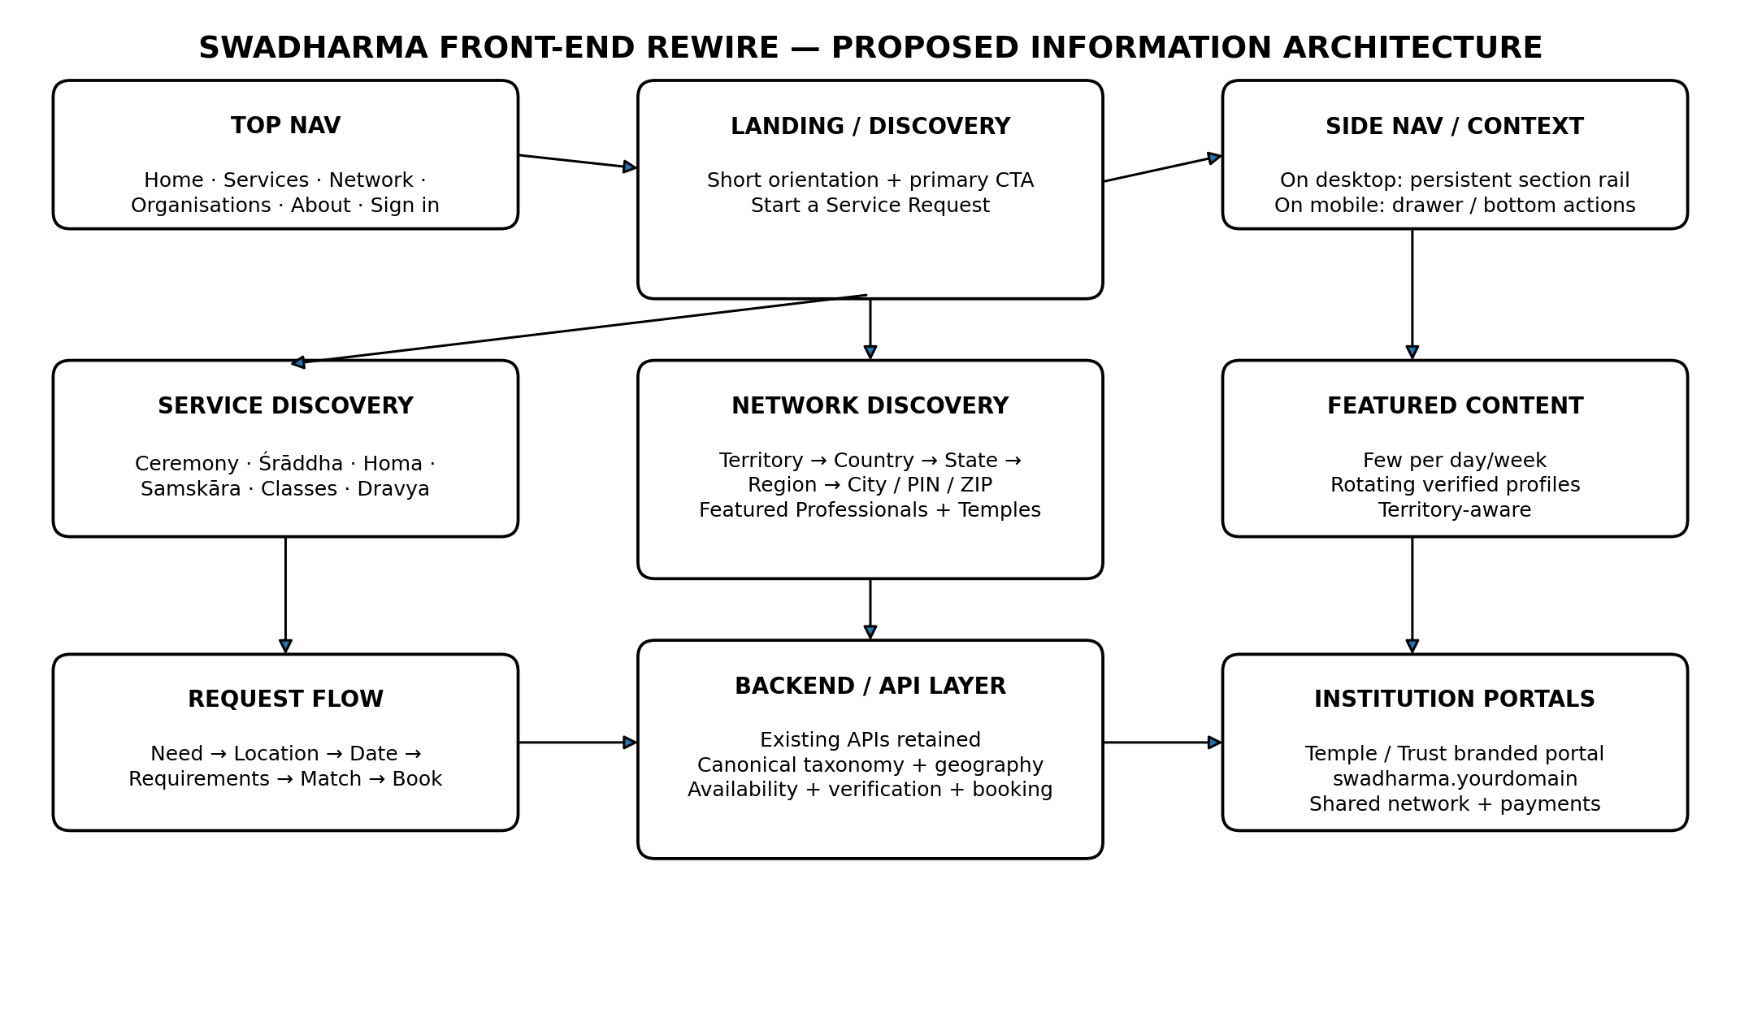

1. Executive Direction
The current public page contains useful capabilities but presents too much of the product in one continuous vertical sequence. The redesign should not be a cosmetic restyle. It should rewire the front end around two layers:
- Public discovery layer — concise, navigational, searchable and territory-aware.
- Application layer — task-oriented dashboards for devotees, professionals and institutions.
The current page already exposes the major domain objects: devotees, service professionals, institutions, services, payments, service manual and organisation subscriptions. The objective is to make those objects discoverable through a coherent information architecture.

2. Recommended Navigation Model

Top Navigation — global
- Swadharma / logo
- Services
- Network
- Organisations
- How it Works
- About
- Sign In
- Primary CTA: Start a Service Request

Side Navigation — contextual
Use a persistent left rail on desktop inside the main discovery/application shell. It should change by context rather than repeat the Top NAV.
- Services context: Ceremonies, Śrāddha, Homa, Samskāras, Vedic Events, Classes, Dravya, Pilgrim Support.
- Network context: Professionals, Temples & Organisations, Featured, Recently Verified, By Territory.
- Organisation context: Overview, Features, Pricing, Onboarding, Portal Demo.
- Signed-in app context: Dashboard, My Requests, Engagements, Messages, Payments, Profile.

3. Why Top + Side NAV is preferable here
Problem | Current pattern | Recommended pattern
Too much vertical scrolling | Everything is stacked | Top-level destinations are immediately reachable
Equal visual weight | Every section looks like a landing section | Navigation establishes hierarchy
App vs website confusion | App functions appear on marketing page | Public discovery and signed-in app are distinct
Network buried in page | Search appears after services | Network becomes a first-class destination
Territory is weak | PIN/state/country filters in one block | Territory is a browsing dimension

4. New Public Information Architecture
Recommended primary routes:
Route | Purpose | Primary content
/ | Compact home / discovery | Orientation, service request CTA, featured network, territories
/services | Service catalogue | All ceremony and support categories
/services/:slug | Service detail | What it is, requirements, locations, related professionals
/network | Network hub | Professionals + temples / organisations
/network/professionals | Professional directory | Territory, specialty, language, Veda, availability
/network/temples | Temple / organisation directory | Territory, services, featured institutions
/territories | Territory browser | Country → State/Province → Region → City/PIN
/request | Service request wizard | Need → location → date → requirements → match
/organisations | Institutional offering | Portal proposition, features, pricing, onboarding
/how-it-works | Service explanation | Roles, payments, verification, booking
/manual | Service manual | Detailed operating rules

5. Home Page — do NOT make it a long scroll
- Header / Top NAV
- One compact hero: “What do you need to arrange?”
- Primary action: Start a Service Request
- Secondary actions: Find a Professional / Find a Temple
- Territory selector: Country → State/Province → Region
- Featured Professionals — a small rotating selection
- Featured Temples & Organisations — a small rotating selection
- Service categories — compact grid
- How it works — three steps
- Organisation CTA
- Minimal footer
The homepage should be a gateway, not a catalogue of every feature. Detailed content belongs behind navigation.

6. Territory-Centric Network Design
Territory should be a first-class browsing dimension. Do not treat PIN/ZIP as merely a filter field. The network should support geographic discovery.
Recommended hierarchy:
- Country → State / Province → Region / District → City → PIN / ZIP
Examples of user journeys:
- India → Karnataka → Mysuru → Professionals
- India → Andhra Pradesh → East Godavari → Temples
- USA → Texas → Dallas–Fort Worth → Professionals
- USA → Nebraska → Omaha → Temples & Professionals

7. Featured Professionals & Temples
Yes — feature a few per day/week, but do this as a controlled editorial/algorithmic surface, not as a random list.
Surface | Count | Rotation | Selection
Featured Professionals | 3–6 | Daily | Verified + territory relevance + specialty diversity
Featured Temples | 3–6 | Weekly | Verified + territory relevance + service completeness
Recently Verified | 3–6 | Daily | Recent verification / empanelment
Popular / Active | 3–6 | Weekly | Engagement and availability signals
Every card should expose: name, role, city/territory, specialties, languages, verification state, and a clear action. Avoid giant profile cards.

8. Suggested Data / API Contract for the Front End
Do not hard-code featured content into the HTML. The front end should consume structured endpoints.
- GET /api/territories?level=country
- GET /api/territories/{id}/children
- GET /api/network/professionals?territory=&specialty=&language=&veda=&verified=true
- GET /api/network/organisations?territory=&service=&verified=true
- GET /api/featured/professionals?territory=&period=day
- GET /api/featured/organisations?territory=&period=week
- GET /api/services
- POST /api/service-requests
The actual endpoint names can follow the existing backend. The important requirement is the separation of concerns: territory, network, services, featured content and requests should be independently queryable.

9. Front-End Component Architecture
- AppShell
- TopNav
- SideNav
- Breadcrumbs
- TerritorySelector
- ServiceGrid
- ProfessionalCard
- OrganisationCard
- FeaturedRail
- NetworkFilters
- RequestWizard
- ProfileDrawer / ProfilePage
- OrganisationPortalCTA
- Footer
The same ProfessionalCard and OrganisationCard components should be reusable in search results, featured rails, territory pages and service detail pages.

10. Interaction Rules
- No duplicate navigation menus.
- No long page section that repeats the same proposition in different wording.
- Every page must have one primary action.
- Search and filters belong to the directory, not the marketing hero.
- Cards must reveal enough information to decide whether to click.
- Territory selection must persist while browsing the network.
- Featured content must be dynamic and API-driven.
- Mobile: Top NAV collapses to a drawer; contextual Side NAV becomes a horizontal tab strip or drawer.
- Desktop: Side NAV stays fixed only within discovery/application pages; it should not dominate the public home page.
- Use URL routes that represent user intent, not internal database structure.

11. Rewire Strategy — Preserve the Existing Code
Do not start by rewriting the backend. First map the current HTML/JS/API wiring to the new information architecture.
1. Inventory existing routes, components, API calls and data structures.
2. Extract service, professional and organisation data into canonical front-end models.
3. Introduce AppShell + TopNav + contextual SideNav.
4. Move network search to /network and create territory-aware routes.
5. Create Featured API surfaces for daily/weekly rotation.
6. Create the Request Wizard as the primary conversion path.
7. Move pricing/manual/ecosystem detail behind their own routes.
8. Retain the existing signed-in application and connect it cleanly from Sign In.
9. Test desktop, tablet and mobile navigation before visual polish.

12. Definition of Done
- A visitor can understand Swadharma in 10 seconds.
- A visitor can reach Services, Network or Organisations without scrolling.
- A visitor can browse Professionals and Temples by territory.
- A visitor sees a small number of fresh featured profiles without overwhelming the page.
- A user can start a service request from any major service page.
- The public website and application are visually related but functionally distinct.
- No major page depends on a single enormous vertical landing page.
- The architecture allows new services, territories, professionals and temples to appear without editing page markup.

Appendix A — Suggested Screen Map
Screen | Purpose
Home | Discovery + featured network
Services | Service catalogue
Service Detail | Service information + request CTA
Network | Professionals / Temples choice
Professionals | Territory + specialty directory
Professional Profile | Verified profile + services + request
Temples | Territory + service directory
Temple Profile | Institution profile + services + booking
Territories | Country → state → region → city
Request Wizard | Structured intake
Organisations | Institutional product
App Dashboard | Signed-in user workspace

Appendix B — Current Site Findings
The live page currently exposes a top navigation, a large hero, an embedded app explanation, join/find/payment/understand sections, service cards, network search, organisation onboarding, pricing, suite information and contact information in one continuous page. That is precisely why the redesign should emphasize information architecture rather than another visual skin.
Source reviewed: Swadharma Services public landing page, swadharmaservices.in/index.html.

